# Department of Computing

# CS370: Artificial Intelligence

# Class: BSCS-5AB

# Lab 4: Games

# Date: 13-10-2017

# Time: 10am-1pm & 2pm-5pm

# Instructor: Dr. Omar Arif

# Lab 4: Games

**Introduction**

Minimax is a decision rule used in game theory for minimizing the possible loss for a worst case (maximum loss) scenario. It is formulated as zero-sum game theory where players take alternate moves.

Alpha-beta pruning is a search algorithm that seeks to decrease the number of nodes that are evaluated by the minimax algorithm in its search tree.

Expecitmax is a specialized version of minimax, where the opponent is playing sub-optimally. The behavior of the opponent is model probabilistically.

**Objectives**

In this lab you will implement minimax, alpha beta pruning and expectimax algorithms for pacman agent.

**Lab Task**

Implement Questions 2,3 and 4 of <http://ai.berkeley.edu/multiagent.html>

Algorithms pseudo code

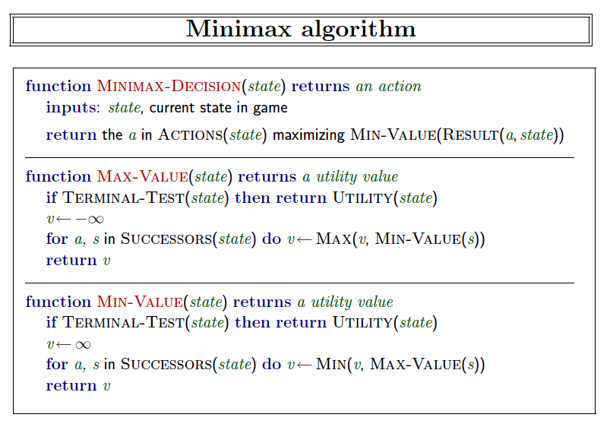

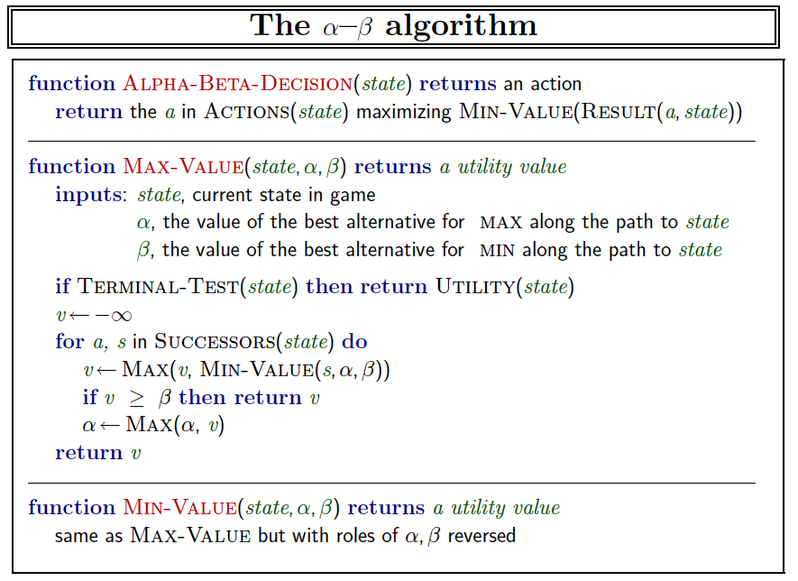

Expecimax is similar to minimax except that you should average the values for the exp player.

**Note:** You can work in groups of 2 but not more than 2.

**Deliverables:** Submit multiAgents.py (**each member should submit the files on LMS).**

**Deadline:** Before the next lab.

### Question 2 (5 points): Minimax

Now you will write an adversarial search agent in the provided MinimaxAgent class stub in multiAgents.py. Your minimax agent should work with any number of ghosts, so you'll have to write an algorithm that is slightly more general than what you've previously seen in lecture. In particular, your minimax tree will have multiple min layers (one for each ghost) for every max layer.

Your code should also expand the game tree to an arbitrary depth. Score the leaves of your minimax tree with the supplied self.evaluationFunction, which defaults to scoreEvaluationFunction. MinimaxAgent extends MultiAgentSearchAgent, which gives access to self.depth and self.evaluationFunction. Make sure your minimax code makes reference to these two variables where appropriate as these variables are populated in response to command line options.

Important: A single search ply is considered to be one Pacman move and all the ghosts' responses, so depth 2 search will involve Pacman and each ghost moving two times.

Grading: We will be checking your code to determine whether it explores the correct number of game states. This is the only way reliable way to detect some very subtle bugs in implementations of minimax. As a result, the autograder will be very picky about how many times you call GameState.generateSuccessor. If you call it any more or less than necessary, the autograder will complain. To test and debug your code, run

python autograder.py -q q2

This will show what your algorithm does on a number of small trees, as well as a pacman game. To run it without graphics, use:

python autograder.py -q q2 --no-graphics

***Hints and Observations***

* The correct implementation of minimax will lead to Pacman losing the game in some tests. This is not a problem: as it is correct behaviour, it will pass the tests.
* The evaluation function for the pacman test in this part is already written (self.evaluationFunction). You shouldn't change this function, but recognize that now we're evaluating *states* rather than actions, as we were for the reflex agent. Look-ahead agents evaluate future states whereas reflex agents evaluate actions from the current state.
* The minimax values of the initial state in the minimaxClassic layout are 9, 8, 7, -492 for depths 1, 2, 3 and 4 respectively. Note that your minimax agent will often win (665/1000 games for us) despite the dire prediction of depth 4 minimax.

python pacman.py -p MinimaxAgent -l minimaxClassic -a depth=4

* Pacman is always agent 0, and the agents move in order of increasing agent index.
* All states in minimax should be GameStates, either passed in to getAction or generated via GameState.generateSuccessor. In this project, you will not be abstracting to simplified states.
* On larger boards such as openClassic and mediumClassic (the default), you'll find Pacman to be good at not dying, but quite bad at winning. He'll often thrash around without making progress. He might even thrash around right next to a dot without eating it because he doesn't know where he'd go after eating that dot. Don't worry if you see this behavior, question 5 will clean up all of these issues.
* When Pacman believes that his death is unavoidable, he will try to end the game as soon as possible because of the constant penalty for living. Sometimes, this is the wrong thing to do with random ghosts, but minimax agents always assume the worst:

python pacman.py -p MinimaxAgent -l trappedClassic -a depth=3

Make sure you understand why Pacman rushes the closest ghost in this case.

### Question 3 (5 points): Alpha-Beta Pruning

Make a new agent that uses alpha-beta pruning to more efficiently explore the minimax tree, in AlphaBetaAgent. Again, your algorithm will be slightly more general than the pseudocode from lecture, so part of the challenge is to extend the alpha-beta pruning logic appropriately to multiple minimizer agents.

You should see a speed-up (perhaps depth 3 alpha-beta will run as fast as depth 2 minimax). Ideally, depth 3 on smallClassic should run in just a few seconds per move or faster.

python pacman.py -p AlphaBetaAgent -a depth=3 -l smallClassic

The AlphaBetaAgent minimax values should be identical to the MinimaxAgent minimax values, although the actions it selects can vary because of different tie-breaking behavior. Again, the minimax values of the initial state in the minimaxClassic layout are 9, 8, 7 and -492 for depths 1, 2, 3 and 4 respectively.

Grading: Because we check your code to determine whether it explores the correct number of states, it is important that you perform alpha-beta pruning without reordering children. In other words, successor states should always be processed in the order returned by GameState.getLegalActions. Again, do not call GameState.generateSuccessor more than necessary.

**You must *not* prune on equality in order to match the set of states explored by our autograder.** (Indeed, alternatively, but incompatible with our autograder, would be to also allow for pruning on equality and invoke alpha-beta once on each child of the root node, but this will *not* match the autograder.)

The pseudo-code below represents the algorithm you should implement for this question.

To test and debug your code, run

python autograder.py -q q3

This will show what your algorithm does on a number of small trees, as well as a pacman game. To run it without graphics, use:

python autograder.py -q q3 --no-graphics

The correct implementation of alpha-beta pruning will lead to Pacman losing some of the tests. This is not a problem: as it is correct behaviour, it will pass the tests.

### Question 4 (5 points): Expectimax

Minimax and alpha-beta are great, but they both assume that you are playing against an adversary who makes optimal decisions. As anyone who has ever won tic-tac-toe can tell you, this is not always the case. In this question you will implement the ExpectimaxAgent, which is useful for modeling probabilistic behavior of agents who may make suboptimal choices.

As with the search and constraint satisfaction problems covered so far in this class, the beauty of these algorithms is their general applicability. To expedite your own development, we've supplied some test cases based on generic trees. You can debug your implementation on small the game trees using the command:

python autograder.py -q q4

Debugging on these small and manageable test cases is recommended and will help you to find bugs quickly. **Make sure when you compute your averages that you use floats.** Integer division in Python truncates, so that 1/2 = 0, unlike the case with floats where 1.0/2.0 = 0.5.

Once your algorithm is working on small trees, you can observe its success in Pacman. Random ghosts are of course not optimal minimax agents, and so modeling them with minimax search may not be appropriate. ExpectimaxAgent, will no longer take the min over all ghost actions, but the expectation according to your agent's model of how the ghosts act. To simplify your code, assume you will only be running against an adversary which chooses amongst their getLegalActions uniformly at random.

To see how the ExpectimaxAgent behaves in Pacman, run:

python pacman.py -p ExpectimaxAgent -l minimaxClassic -a depth=3

You should now observe a more cavalier approach in close quarters with ghosts. In particular, if Pacman perceives that he could be trapped but might escape to grab a few more pieces of food, he'll at least try. Investigate the results of these two scenarios:

python pacman.py -p AlphaBetaAgent -l trappedClassic -a depth=3 -q -n 10

python pacman.py -p ExpectimaxAgent -l trappedClassic -a depth=3 -q -n 10

You should find that your ExpectimaxAgent wins about half the time, while your AlphaBetaAgent always loses. Make sure you understand why the behavior here differs from the minimax case.

The correct implementation of expectimax will lead to Pacman losing some of the tests. This is not a problem: as it is correct behaviour, it will pass the tests.